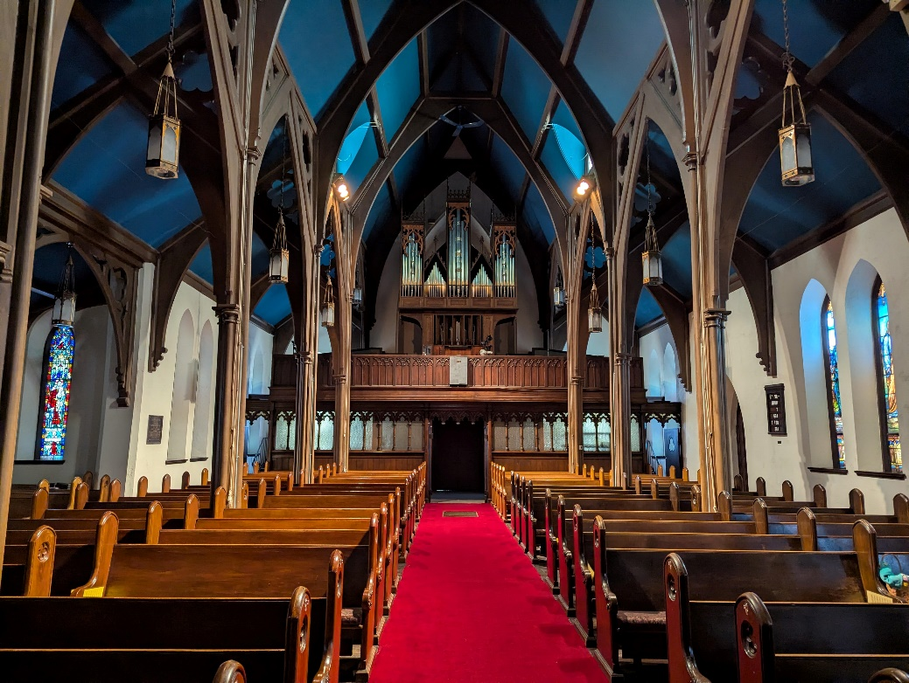
Part-time Music Director Wanted: Zion Episcopal Church, Rome, NY
Zion is a warm and resilient community that has faced numerous challenges over the last few years. The congregation and leadership have recently taken steps to commit ourselves to renewal and growth, and we are seeking a vibrant, creative, and multidimensional music program to join this effort.
While the successful Music Director candidate needs to have, or be willing to acquire, knowledge of sacred choral music, hymns, organ repertoire, and Episcopal Liturgical practices, Zion Rome is willing to find ways to support a Music Director as they work to learn those skills. So, we encourage those from a variety of musical backgrounds and traditions to apply. Drawing from their background and unique expertise, the Music Director will provide the leadership necessary to meet the mission and vision of the music program specifically and the mission of Zion Church generally.
Title: Music Director, permanent, part-time (Approx. 15 hours per week)
Salary Range: $16,000-20,000 annually
Reports to: The Priest-in-Charge
Full job description can be found here or on our website: zionrome.org

